

Core Version

User Guide (Update V13.6)

I. Install and Get Started 4

A. Install SQL Server Express 4

B. Install Crystal Report 5

C. Install OpenCBS Software 5

D. Access the software 6

II. First Step in the Software 8

A. Dashboard 8

B. Easy Menu 9

C. Alert Window 9

D. Top Menu 9

III. Settings 9

A. General Settings. 9

B. User Settings. 10

C. Database Control Panel. 11

D. Database Maintenance. 11

E. Change Application Date 12

IV. Configuration 12

A. Configure Branches. 12

B. Configure Tellers. 13

C. Client Data Fields. 13

D. Economic Activity 14

E. Region, District, Cities 14

F. Funding Lines 14

G. Installment periodicity 15

H. Currencies and Exchange Rate 15

V. Audit and Controls 15

A. Roles 15

B. Users 16

C. Audit Trail 16

VI. Products 17

A. Loan Product 17

1. Main parameters Tab 17

2. Fees 18

3. Exotic Installment 19

4. Credit Line 19

5. Guarantees 19

6. Credit Assurance. 20

B. Saving Product. 20

1. Main Parameters 20

2. Transactions 21

3. Fees 22

4. OverDraft 23

5. Term Deposit 23

*C.* Collateral Product 23

VII. Client and Contract 24

A. Create Individual Client 24

B. Create Group or Corporate Client 24

C. Create Loan Contract. 24

1. Choose your client and product. 24

2. Define Loan Details. 25

3. Advanced Settings. 25

4. Guarantors and Collaterals. 26

5. Credit Committee. 26

6. Confirm Disbursment. 27

D. Manage Loan contract 27

1. Search Contract and access Schedule 27

2. Repay. 28

3. Reschedule 29

4. Disburse Credit Line Tranche. 29

5. Write off. 30

6. Event Management. 30

E. Create and Manage Saving Contract. 30

F. Reassign Contract 31

VIII. Accounting 32

IX. Reports 32

A. Standard Reports. 32

B. Custom Reports 32

C. Legacy Reports 32

D. Internal Form 32

X. Window and Help 33

# Install and Get Started

OpenCBS System requirements are relatively low. As such the system could be installed on any computer with windows as operating system. If you are facing issues in the installation process thanks for contacting us at the following address.

OpenCBS is a system working as an interface between the user (you ☺) and a database containing the information about your microfinance activity. As such using OpenCBS requires the installation of a database management system, in our case SQL Express. The reporting section of the software requires as well the installation of Crystal Report Viewer, the software managing the visualization of report in the software.

## Install SQL Server Express

Start by download SQL Express on the following page. (<http://www.microsoft.com/en-us/download/details.aspx?id=7593>) This software is free to download. Be cautious to choose the right version as per the operating system you are using (Explanation to be written here).

Once Downloaded, launch the setup and go through the installation steps being cautious of the followings:

* At the Feature selection step, don’t forget to select the manager if you want to be able do maintenance of the DB through SQL Server management.
* At the Instance configuration step, choose a name you will remember as you will need it to connect OpenCBS to your SQL Database. We advise you to name it SQLExpress to make it easy

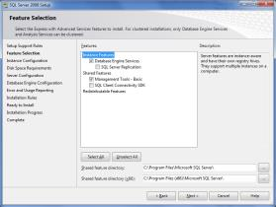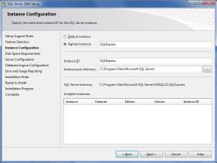

* At the server configuration step, choose an automatic startup type and you can disable the SQL Server Browser. (Cf Screenshot)

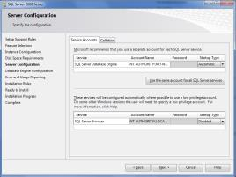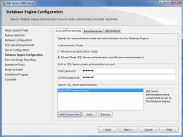

* At the step of database Engine Configuration you have to choose the type of identification mode you want to use to connect to the databases stored in SQL Express. At this specific step, chose mixed mode and choose and identification ID and a password. Important! Keep this password as it will be required to connect your OpenCBS to your database system.

## Install Crystal Report

Crystal report reader can be downloaded for free at the following address .( <http://scn.sap.com/docs/DOC-29774> )Once downloaded, launch the setup and follow default type installation of the system. Just note that no product ID is required as the software is available for free.

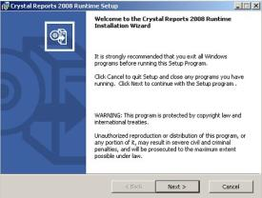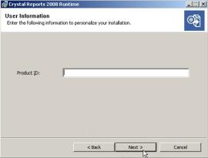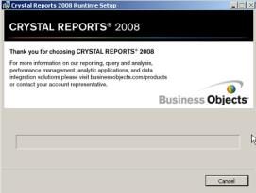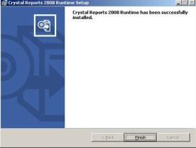

However if you want to create your own reports, you will need Crystal report Creator available at the following address: <http://www54.sap.com/solution/sme/software/analytics/crystal-reports/index.html>

## Install OpenCBS Software

Download the ‘’MSI’’ file available at the following address: [www.dropbox.com/s/uwdr1u1ltfkjao6/opencbs-13.5.118.537d0bb.msi](http://www.dropbox.com/s/uwdr1u1ltfkjao6/opencbs-13.5.118.537d0bb.msi) once downloaded, launch the setup and follow default type installation of system.

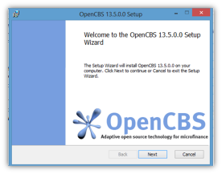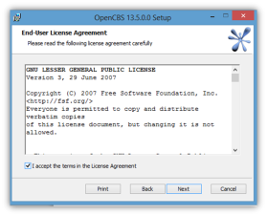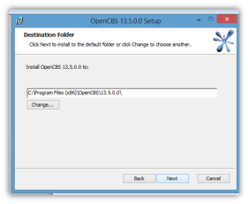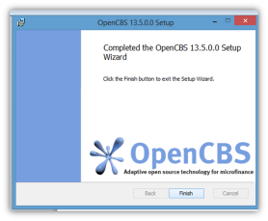

## Start OpenCBS

The first time you start the system, you will first arrive on a window called ‘’Database Control Panel’’. At this step you will connect your OpenCBS to the SQL Database stored in SQL Express.

In Server Name section you should enter the location of your SQLExpress System. If you followed standard installation process, just click default and the proper address should appear. Then enter you login name as well as you password to access the next step.

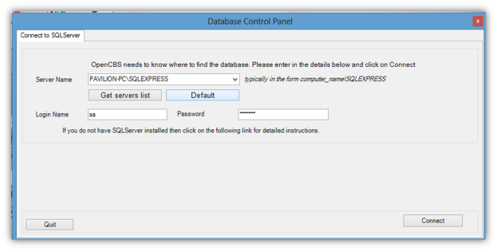

***Note:*** *Please note that in that case you are working on a network of several computer on one single database stored on the branch server for instance, it is at this level that you should connect your OpenCBS directly to the database of the server(Example BranchServer\SQLEXPRESS if the server name is BranchServer). Find more details in the* ***‘’Workshop******I set up my network of computer connected to one single OpenCBS Database’’***

After connection, the OpenCBS databases available in SQL Express will appear in a section ‘’database management’’. If you are using the software for the first time this section will be empty and you will have in that case to create a new database. If you already used OpenCBS with your SQL you should see appear the databases you already created, including the version of the Software compatible with this database, the size of the DB as well as the code of the DB (to be configured later usually corresponding to name of branch or organization.

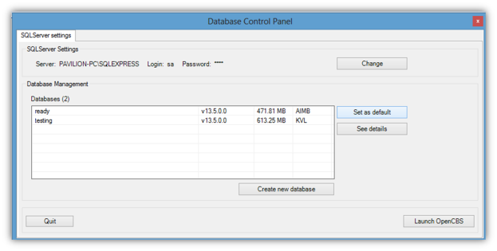

The database located at the top of the table will be the one started automatically if you launch the software. Select the database you want to restore and click the “Set as Default” Button to change this order. You can as well check compatibility of the database with your version of the software by clicking on “See Details”. Once you are sure about compatibility click Launch OpenCBS to start the software.

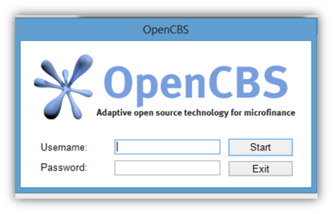

If you are starting a new Database, the default ID and passwords are (admin, admin). If you are using an already exisiting database you should remember it or find it back through SQL server Management. For more details on this consult **“Workshop. I use SQL Server Management to perform maintenance of my database”**

This done you should be inside the software. Congratulation you are ready to start working.

# First Step in the Software

You are now on the starting window of OpenCBS.

## Dashboard

The white part of the window contains your operations dashboard. The first section gives you key date about the risk detailing the portfolio at risk in amount, in number of loan and in number of days late in the portfolio stored in the database.

The second section gives you a snapshot of the productivity of operations with the number of disbursement and the OLB variation of your portfolio in the last 10 days

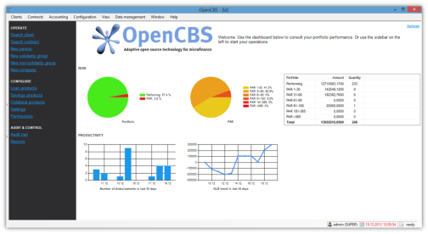

## Fast Access Menu

The Black layer on the left is a fast access menu to perform the main key operation tasks inside the software

## Alert Window

On the left of the screen by clicking on the double arrows, you can extend an alert window. This alert window can display the following 6 type of products which could require your attention:

Late loans, Pending Loans (Waiting to be evaluated), Postponed Loans (Loans to be reevaluated later), Validated Loans (Loans waiting to be disbursed), Pending Savings (Saving accounts waiting to be officially open), Overdraft Savings (Savings with balance below 0)

You can as well customize the top bar menu the way you want as per the info you want to display in this alert window

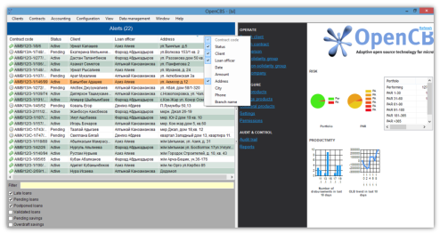

## Top Menu

Then as any other software, all functions are accessible through the menu at the top of the window. In open CBS the following 9 menus:

1. Settings

2. DB Configuration

3. Controls and Security

4. Products

5. Clients and Contracts

6. Accounting

7. Report

8. Help

9. Windows

The following parts of this user guide are structured as per these menu items from left to right

# Settings

This section enables you to choose your system settings. It contains 3 links:

## General Settings.

Enables you to adjust a number of parameters related to calculations and temporal management of your system. For clearer explanation of what line means please follow this link. Overall if you are using standards week system with weekends on Saturday and Sunday, we advise you to keep the standard configuration. For any questions on general settings thanks for contacting us.

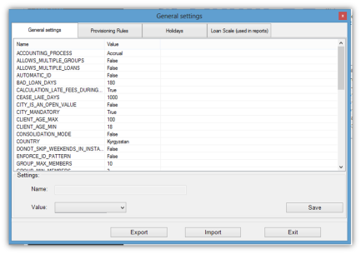

*Provisioning rules* where you can configure the provision rules of your institution. It will impact the related reports and some parts of the accounting section of the system

*Holidays.* Enter the public holidays in your country of operations

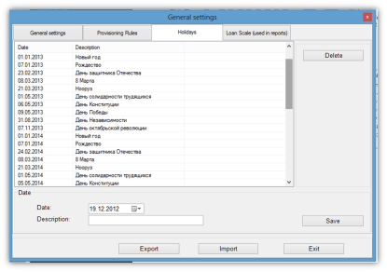

*Loan Scales*. Partition between loans per loan size you would like to see appear in your portfolio analyze report

## User Settings.

Defines language and paths for backup export and consolidation.

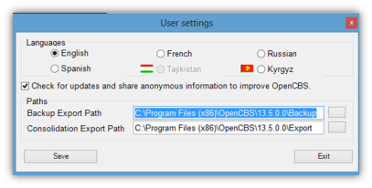

## Database Control Panel.

Here you can starting from top of the window:

Change the SQL server you are connected to. It happens for example if you want to connect your self to the backup located on the server of a branch while you were working before on a DB hosted on your computer.

Switch to another database than the one you are currently using, see details about any of the DB stored on your SQL, Restore a Database stored somewhere on your computer or do the backup of the database you are currently working on. 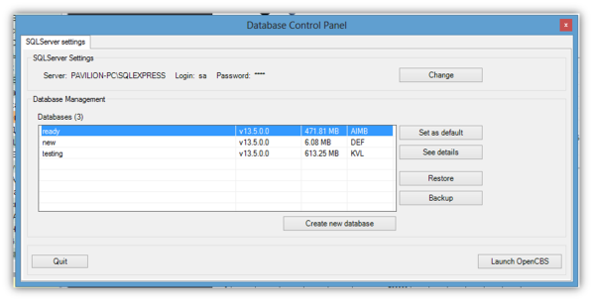

You can as well create a new database to start from a blank sheet.

After operating your changes the button Launch OpenCBS will restart the system on the database you ended up choosing.

## Database Maintenance

2 Additional options in this window: Shrink the database to reduce its size and enable you to send it more easily. Enter an SQL quiery, to apply an SQL quiery on your database directly from the software. To be used for maintenance only and preferably after consulting OpenCBS Help Desk Team on the issue you are facing

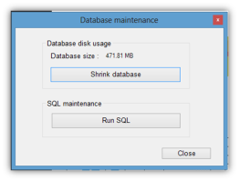

## Change Application Date

For maintenance purpose, or if you want for example to enter a transaction or print a report as per a different date than the date of operations, this item enables you to do it.

# Configuration

This section of the software enables you to define all the specificities of the operations you will be managing with this OpenCBS Database.

## Configure Branches.

To use in case you intend to manage several branches with the same database and connect them remotely through network or internet to this centralized DB. Add, Edit and Delete Branches using the right side menu. (Note: Code Name will impact your contract number, if you include in the code name format)

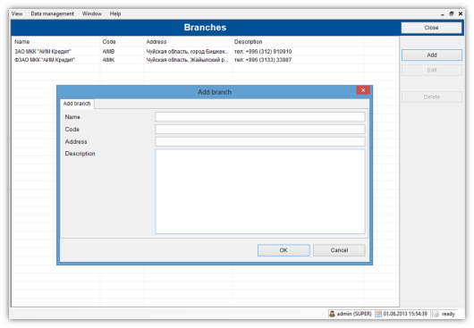

## Configure Tellers.

To be used to insert teller control inside OpenCBS. Use the right side button to manage them. For adding a teller you need 1. To enable the function in general settings 2. To create accounts for tracking balance of these tellers. Through this section you can as well create a Vault by ticking the option below. In such case you don’t attach the teller to any user of the software. The Advanced section enables you to setup limits in amount for the operations of this teller.

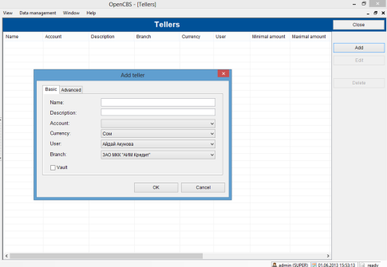

## Client Data Fields.

In this section define all the information you want to track for Individuals, Solidarity Groups, Non Solidarity Groups, Corporate, Loans and Savings. For each category you can define as many customizable fields as you want through. Each fields can be as one of the following category (Boolean(Yes or no), Number, String (list of character), Date, Collection(multiple choice), Client). These fields can be made mandatory or not in the entry of data. Important! Once value are entered for one field, the field cannot be deleted anymore.

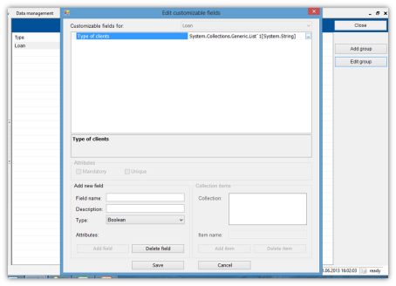

## Economic Activity

Define here the economic activities (and sub economic activities) of your clients. These categories will appear as option while entering your client information and will then be displayed in some statistic reports.

## Region, District, Cities

Same idea than for economic activity. Define here the locations of your clients to see them appear as option which you save their profile in the software.

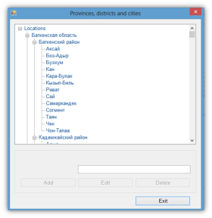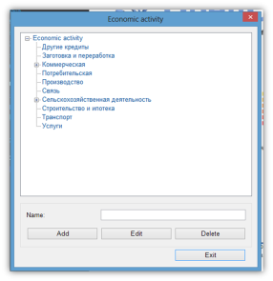

## Funding Lines

Enter the funding line used by your institution. Main characteristic of the funding line are at the top. The bottom part help you manage transactions related to this funding line. Usually after creation of the funding line, you enter the initial credit of the line. Afterwards, transactions like disbursements or repayments can be connected to the funding line when they are being confirmed at the contract level.

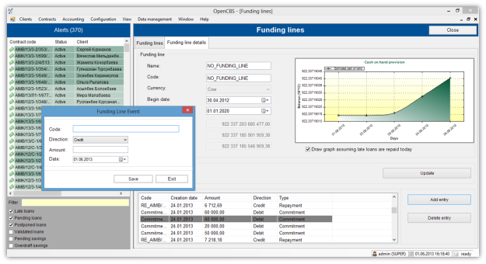

## Installment periodicity

Define here all the types of periodicity for installment you are using in your products. The options you create will then be available at the loan product creation level.

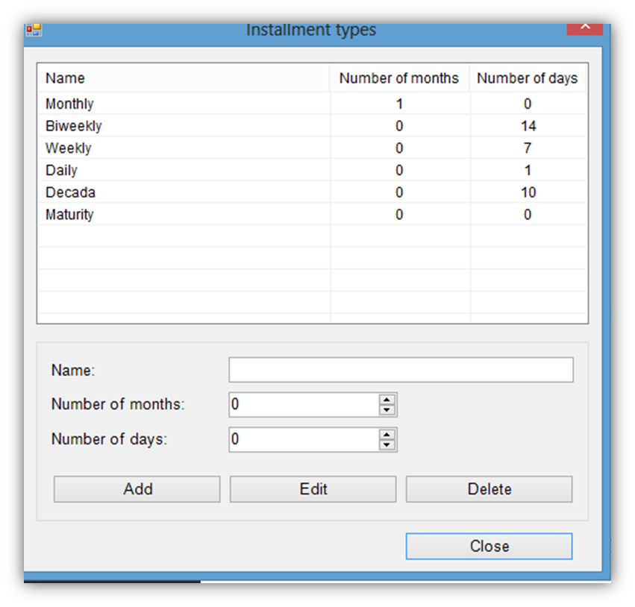

## Currencies and Exchange Rate

Enter here characteristics of the currencies you are using in your activity. OpenCBS can work for 1 or 2 currencies. For each calendar you can define here the exchange rate between the 2 currencies you are using in your system.

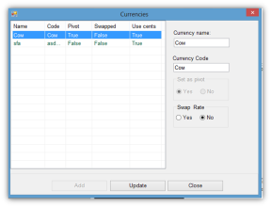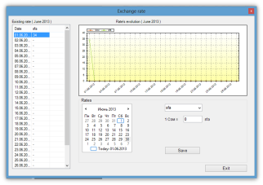

# Audit and Controls

This sections enables you to configure your system to ensure the security of the operations performed on the software through good segregation of tasks and proper tracking of performed operations

## Roles

Here you will define the permissions to be given in the software to the staff of your institution as per their ‘’Role’’ (or position) in the organization. By default the software give 5 Roles (ADMIN, Cashier, LOF, SUPER, VISIT), up to you to adapt these categories as per your organizational structure and the responsibilities of your staff with the software. The right part of this section enables you to choose specifically what ‘’Menu Items’’ the role will be able to access and what ‘’actions items’’ they will be allowed to perform. Take the necessary time to perform this properly or consult our ‘’Workshop How to efficiently integrate my software in my daily operations’’

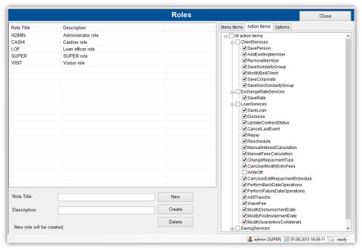

## Users

Once the roles defined, you will create here the user profile of the staff of your organization. You have to enter people who will be using the software as well as the credit agent who will be in charge of the contracts entered in the system. Note: By Default there is only one user in the system (Admin, Admin). You can as well change your password using the change password function and this even if you don’t have permission to access the user section

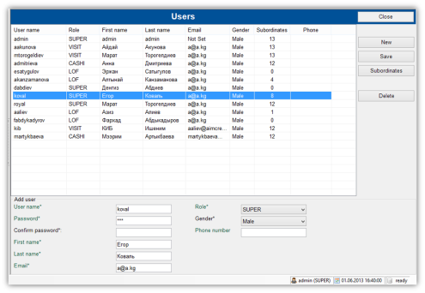

## Audit Trail

The audit trail enables you to see the transaction by type performed during a specific period and by whom they have been perfomed. This section enables you to track who performed what and when and as such add a level of control on the tasks performed in the software.

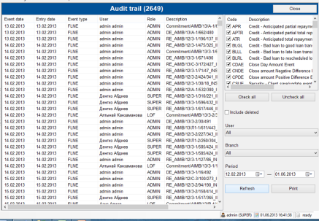

# Products

Your Database is now configured, you entered profile and permissions for the people who will be operating it, you can now start creating your products. OpenCBS propose a very developed and complete loan product section as well as a saving section enabling you to create saving books. Collaterals to be attached to your loans are as well managed as product through this part of the software

## Loan Product

In the loan product section you can find the library of product already created in the software including the deleted one if you tick the upright option

.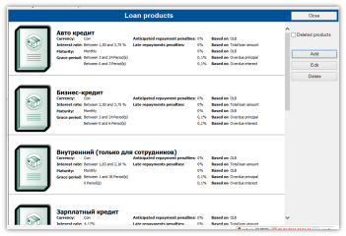

The product creation window contains six tabs:

### Main parameters Tab

At this level you define all key parameters of your schedule. Type of installment, grace period, amount, Interest etc.… Please note that for each of these categories you can either fixed one specific amount either state a range of value you will have the possibility to choose at the disbursement level. Please note that you can have characteristics of the product evolve by loan cycle by ticking the option use loan cycles in the advanced parameters section

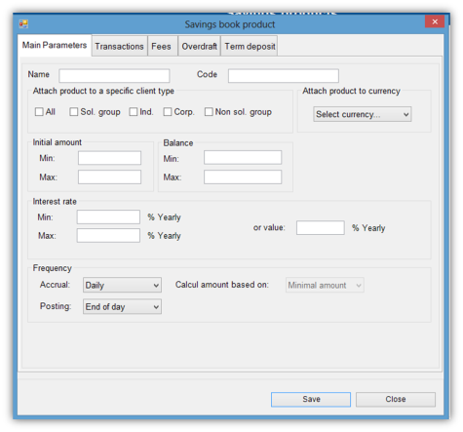

### Fees

Second. most important Tab. Define here what type of entry fee, late fees and prepayment fee you want to apply to your client. Note that you have the possibility to have different type of entry fees and you can as well make them evolve through loan cycles by ticking the ‘’use loan cycle’’ option.

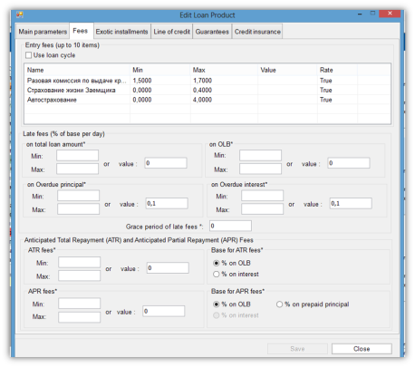

### Exotic Installment

Using exotic installment means that you will not use any predefined format of calculation and will just define yourself through the installments the % of the Total Interest and Total Principal you will have to repay. The flexible schedule is an option you have at the disbursement level to do your self some manual adjustment on the schedule before disbursements. We advise you to enable it and to use the Roles section of the software to ensure it is not being used without proper reasons.

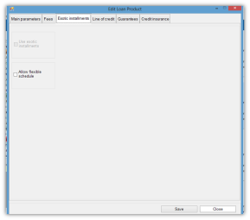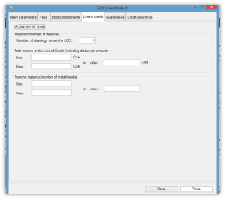

### Credit Line

Capacity to use credit line inside the product. The first option is the total number of tranches allowed the second the total amount, the third is the maturity for tranches. Note that this last option is taken into account only for additional tranches. For the first tranch disbursement in main parameter is taken. As such you should ensure that max amount is above the initial amount disbursed.

### Guarantees

Here defines if guarantors or collaterals are mandatory for disbursing these loans and what percentage of the loan amount these guarantees must cover. Note that you can have percentage for collateral ad guarantor value together or separated. Last section refers the mandatory savings the loan might require to be disbursed. It can be defined as flat amount or as a percentage of the loan amount.

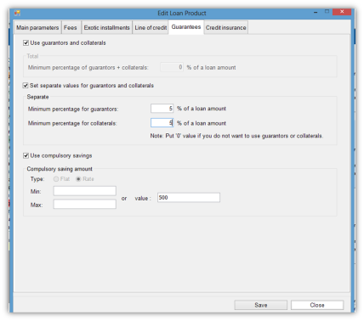

### Credit Assurance.

It is an amount withdrawn from the loan as an insurance in case of failure to repay. It is an option to use to include for example a life insurance in the product, to cover yourself against potential client death.

**Note: To get in a snapshot the full information on the Loan functional Coverage of OpenCBS please consult OpenCBS Functional Tree**

## Saving Product.

Like for loans, you can find here the library of product of your database. 5 tabs are used to configure your saving products:

### Main Parameters

Product information, name, code, limits of deposit and at the bottom of the page yearly interest rate on the product and calculation of accrued interest.

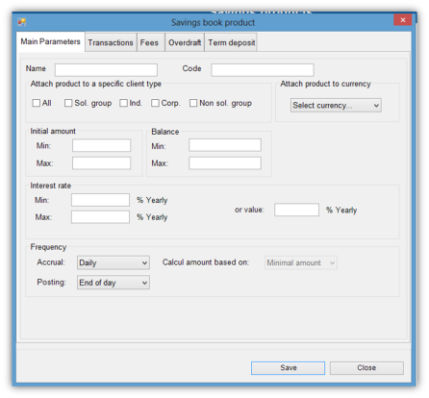

### Transactions

Price of all the type of transaction which can be performed on the deposit account. Please note that you should define it for both Cash and Check deposit by adjusting the parameter at the top. Please note as well that different rate can be established for intra-branch transfer and inter-branch transfers. Note as well that amount can be defined either flat either as a rate of the transaction and you can either define a range of value or a fixed one, like on some parameters of the loan.

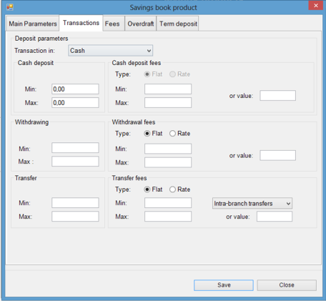

### Fees

Fees related to special steps of the process of deposit. Please note that the re-open fee is for accounts which have been created, then closed and now want to be reopened. The management fee is the cost of maintenance of the account.

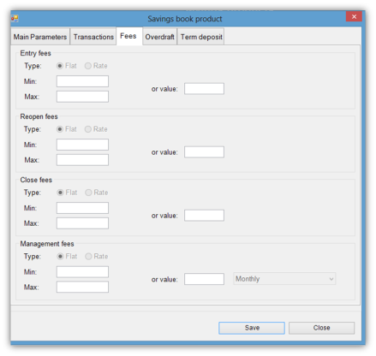

### OverDraft

Fixed overdraft fees is actually the amount allowed in overdraft to be defined either as a percentage of the deposit amount either as an amount. The Agio is the cost of the overdraft in percentage of the overdraft amount or as a fixed value.

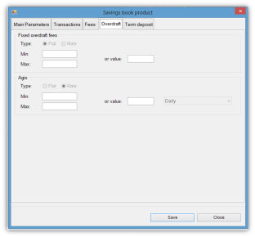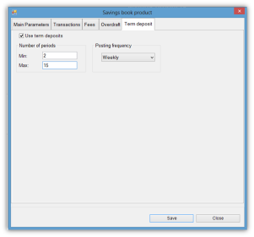

### Term Deposit

It enables you to block the deposits for a certain period of time to make your fixed deposit a term deposit product.

## Collateral Product

The collateral products to be later attached to the loans, can be created through the same type of interface than the customizable field section in Configuration part. As many characteristics as wanted, characteristics which can be either numbers, string, Date, Collection (multiple choice) or Owner (Individuals to be registred in the DB). We advise you to enter here the standard collaterals used in your context of operations, it will make you able to track all your collaterals directly through the software.

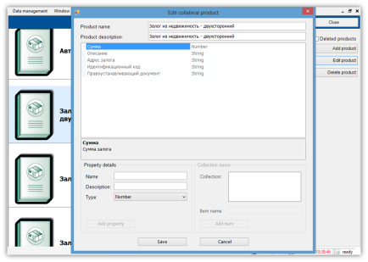

# Client and Contract

## Create Individual Client

Complete the page as per the data of your client. The fields with * are mandatory. For Economic activity, Branch and Address fields you find back the item defined in the IV. configuration section of the software. You can as well add pictures of the client or of his shop. The picture files will be stored in an independent database. In the customizable field tab, you’ll find back the fields defined in IV. Configuration. Member of displays the group the client belongs to. It should be empty if the client is new. You can as well print reports related to this client information, for this check the Workshop Create my internal forms to be printed from OpenCBS. Don’t forget to save after completing the filing.

## Create Group or Corporate Client

**Create Solidarity Group Client.** Define the characteristics of your group in the Details, address and customizable sections like for individual clients and affect individual clients to the group through the Tab ‘’members’’. ‘’History’’ Tab should be empty if it is a new group as it gives info on individuals having left the group.

**Create Non Solidarity Group.** Same idea than for the Solidarity Group, except that in these groups, you give product individually. As such you need to affect members to the group as well as the product of these members. The Group purpose is here mainly based on commun meeting participation, to be defined in the Tab ‘’Meetings’’

**Create Corporate Client.** Same system than for other type of clients except that here one individual has to be attached to the company through the ‘’Contacts’’ tab of the window.

## Create Loan Contract.

### Choose your client and product.

Start by creating or finding in the database the client you want to affect a product too. For this use the Search client Function. You can find clients by name, type of activity and by active or non active status.

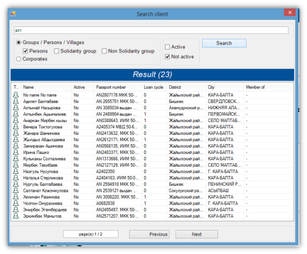

In his profile goes to the tab ‘’Contracts’’ you find here all legacy loans and savings products of this client. Clicking add loan you will have the choice between all the type of products available in the system for this type of client. Choose the one you want.

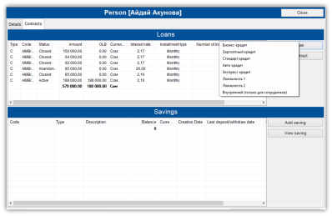

### Define Loan Details.

Here you will have to define all the customizable parameter of the loan product you chose. You will as well define the date of disbursement and the first installment date if your rights allow it. Use the preview option to see what your schedule will look like. Please note that if you put it as a possibility for this product you can Edit Schedule manually using right side button. Don’t forget to fill the customizable fields available in the tab below. Once you are satisfied with the preview and information click save to access next step.

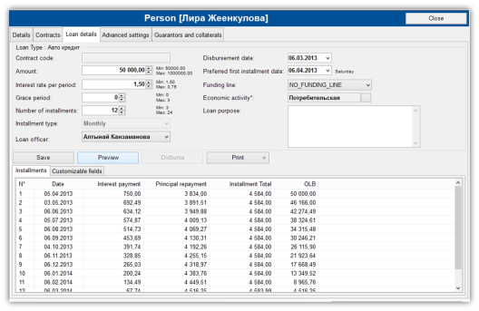

### Advanced Settings.

In this window you will adjust the following parameters Fees, Line of credit, Credit Insurance and compulsory savings as per the characteristics of the loan product. Save for accessing next step.

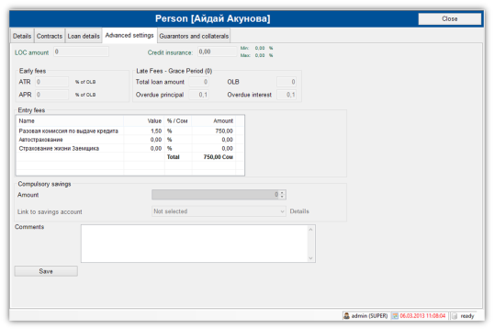

### Guarantors and Collaterals.

If the product requires collateral or guarantor coverage you will be directed to this tab to add pre-entered individuals as guarantor of your client or to enter the characteristic of collaterals put as guarantee. You can see the amount of percentage coverage of the loan amount for each of the chosen collaterals.

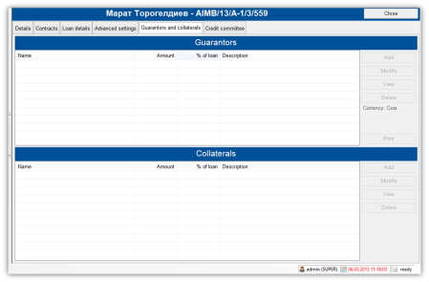

### Credit Committee.

Last step of the loan disbursement process, choose new Status, Date, code and comment. Print Client Appraisal if available and click save to confirm the change of status of the loan. As long as the loan is not disbursed you can change the status of the loan again by clicking on the update button.

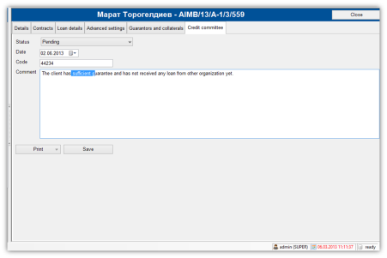

### Confirm Disbursment.

Go back to the Loan Details window. The Disbursement Button is now activated click on it to confirm the disbursement. A last window reminds you details of the disbursement and if available give you possibility to change entry fee and print disbursement receipt. Ok to confirm disbursment. This done Repayment tab appears from where you will manage your repayment schedule trhough the loan.

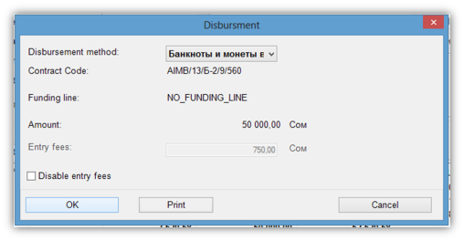

## Manage Loan contract

### Search Contract and access Schedule

To manage your loan start finding them in the database using the Contract Search function enabling you to search loans and savings contracts. Please note that you can type as well the name of a staff to find all the contracts attached to him/her.

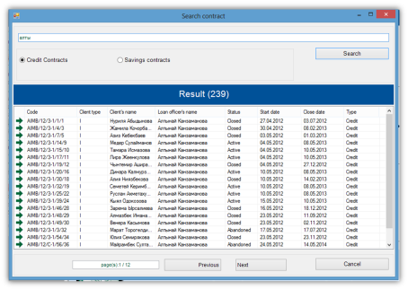

The loans are being managed through a window showing the planned repayments of the loan. The completed repayments are highlighted in green with info on the effective repayment displayed on the right while expected amounts are the left.

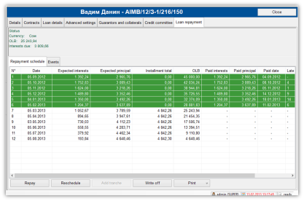

### Repay.

Clicking repayment, a specific window opens where you can adjust (if permission) the parameters of the repayment and especially the amount and its repartition between principal, interest and penalties. Two options are proposed in term of how the schedule will be readjusted after repayment. 1 Keep schedule and nothing wil change or 2. Do not keep schedule and it will be recalculated as per the new OLB after repayment. Use the preview of what your schedule will be after repayment to ensure you perform the changes you expect. Ok to Validate repayment

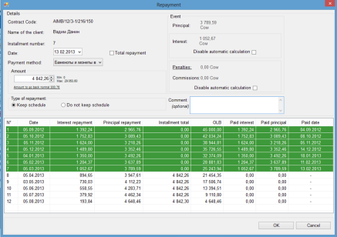

### Reschedule

If the product and permissions allow it, you can perform reschedule on the loan. Through the below interface, you can add grace period from now till next installment, add installment to the schedule, shift the dates of the schedules and even change interest rate. Check properly the preview before validating.

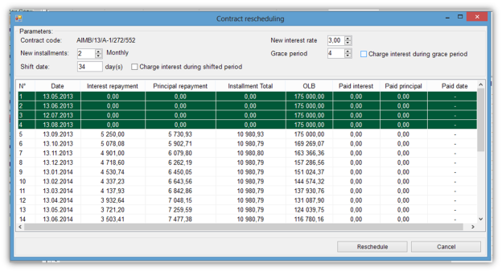

### Disburse Credit Line Tranche.

If you enabled credit line for this loan product, you can disburse additional tranches to the loan. Choose the number of installment of your new tranch, the starting date of the tranch and the interest rate to apply on it. The new tranch will be added to the existing schedule. Use the preview before validating changes.

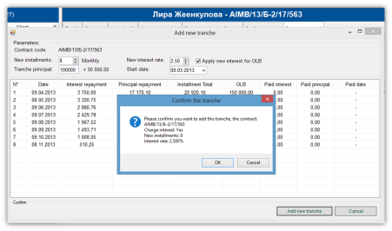

### Write off.

Button to use to take off the loan from the book. Function to be protected by user rights.

### Event Management.

The event tab enable you to see all events performed on the loan. Provided you have the proper user rights, you can retrospectively delete an event or withdraw the penalties from an installment. Deleted events are getting highlighted in green.

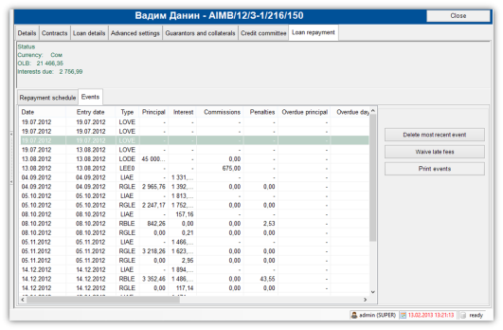

## Create and Manage Saving Contract.

To create saving contracts, choose the type of product you want in the contract section. On the page below define initial characteristics of your saving product at the top and all the specs for fees and limits at the bottom. Click save to confirm creation. This being done you can start performing operations using the dedicated button and follow your Events through the tab available below.

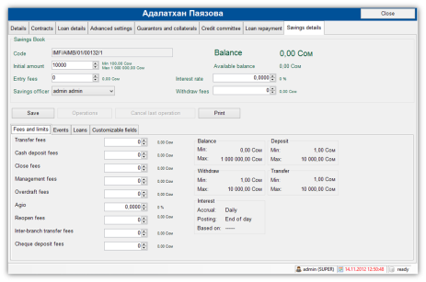

To be developed further soon after savings refactoring

## Reassign Contract

In the case of a staff leaving your institution or for any other reason you can reassign loans from one staff to another using this section.

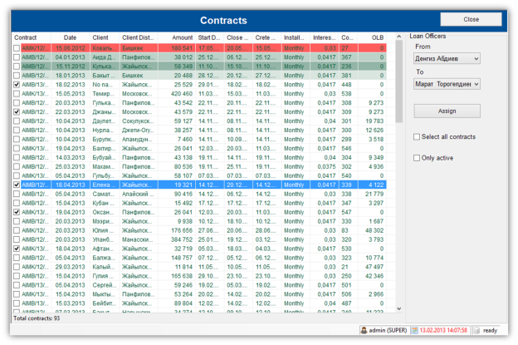

# Accounting

OpenCBS is not an accounting software. It however allows you to do basic accounting follow up of your activity through a universal accounting section.

**Chart of Account.** Define your accounts here

**Accounting Rules.** Create the rules which will connect your loan events with the accounts

**Manual Entries.** Performing accounting entries which are not related to any transactions from OpenCBS Loans or Savings products.

**Standard booking.** Standard booking transaction

**Trial Balance and General Ledger.** Standard Accounting reports formats

**Export Transactions.**Take your accounting transactions out of the system for a potential integration with Tiers accounting system. We can help you in integration of many key systems such as 1C or Quickbooks. Contact us.

**Accounting Closure.** Close your fiscal year.

**Fiscal Year.** Define the fiscal year followed in your organization.

Screen shots to be added from a database with accounting data…

# Reports

## Standard Reports.

The 10 key reports available in the core version of the software: Portfolio Summary, PAR Analyses, Collection Sheet, Delinquent Loans, Active Loans, Disbursements, Repayments, Client Information, Closed Contracts, Accrued Interests.

*Add screenshots of the 10 standard reports after changing design and logos ect…*

## Custom Reports

The reports created just for your need, by us, by yourself or from your local service providers. They can be created through Crystal Report Creator and added in the folder report of your OpenCBS file, to be accessible in this section.

*Add a custom report screen shot here…*

## Legacy Reports

Reports created in the past for very specific needs and for previous version of software. They are free to use. If you face issues of compatibility with the version of OpenCBS you are using, contact us and we will update it for you.

*Add an exotic report screen shot here…*

## Internal Form

You have probably noticed all over the software some ‘’print’’ button. These enables you to print your own internal forms like contract, schedule or receipts directly through the system. By default the software proposes standard format for these forms. If you want to have your own customized format contact us and we will either do it for you either help you get it done by yourself or some of our local partners.

*Add an Internal form screen shot here…*

# Window and Help

Section dedicated to visualize open windows in the software for the first one and to access User guide, Help Desk Forum and About section for the second one.